Individual Development Plan (IDP) – Entrepreneurship Training

Leyla S 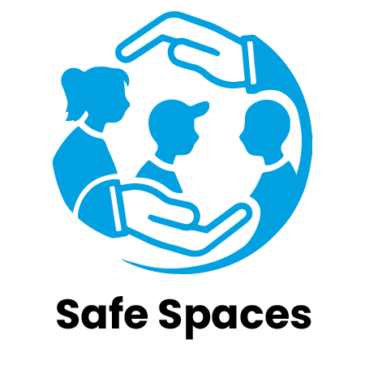

Individual Development Plan (IDP) – Leyla S

1. Background
Leyla S is a 16-year-old unaccompanied minor from Syria, currently living in a youth shelter. She is passionate about storytelling and language, and often writes poems and journals about her experiences. Through the entrepreneurship module at her youth center, she developed the idea of creating a peer storytelling night, where young people could share their personal journeys in a safe, creative space.
Leyla speaks fluent Arabic and is learning Norwegian. She has shown strong initiative and empathy, and hopes to one day use her voice to support others navigating life in a new country.

2. Entrepreneurship Goals
Short-Term (6–12 months):
- - Improve communication skills, especially for public speaking
- - Launch a recurring peer storytelling night at the youth center
- - Learn to design simple flyers and digital invitations
- - Build confidence in organizing and presenting events
Long-Term (2–4 years):
- - Facilitate storytelling activities for newly arrived youth
- - Develop a small digital storytelling platform or blog
- - Explore pathways in youth work, social entrepreneurship, or creative arts

3. Skills Assessment
Strengths:
- - Strong empathy and emotional intelligence
- - Passion for storytelling and communication
- - High motivation and consistency in project work
- - Peer leadership potential
Areas for Development:
- - Public speaking in a second language
- - Event planning and time management
- - Digital content creation (social media, design tools)
- - Confidence in formal outreach and collaboration

4. Development Activities
Focus Area | Development Activity
Communication | Attend conversation groups or drama activities in Norwegian
Digital Tools | Learn to use Canva or Google Slides for visual communication
Facilitation Skills | Co-lead peer storytelling sessions with youth center staff
Creative Expression | Develop a personal blog or zine with translated poems/stories
Peer Leadership | Join or initiate a youth organizing team for events

5. Timeline
Goal / Milestone | Target Completion Date
Organize first storytelling night | November 2025
Create promotional materials for the event | October 2025
Start a personal blog or story-sharing page | January 2026
Facilitate 3–5 storytelling circles | March 2026
Explore opportunities for publishing/zines | Summer 2026

Phase | Milestone
Initiation Phase | Identify core team members and co-design project vision with youth
Engagement Phase | Organize the first storytelling night and gather feedback
Development Phase | Co-create promotional materials and launch a story-sharing platform
Growth Phase | Facilitate 3–5 storytelling circles and deepen youth participation
Exploration Phase | Explore opportunities for publishing, collaborations, or creating a zine
Reflection & Adaptation Phase | Gather stories and feedback to inform the next cycle or direction of work

6. Support and Resources
- - Language Support: Free language cafés and drama groups
- - Digital Learning: Youth center laptop access and Canva workshops
- - Mentorship: Pairing with an older peer or volunteer in the creative field
- - Funding: Mini-grants or materials provided by the youth center
- - Visibility: Promotion through the center’s newsletter or Instagram page

7. Monitoring and Review
- - Bi-monthly check-ins with a youth worker or mentor
- - Self-reflection through journaling after each session or event
- - Regular peer feedback loops from participants
- - Visual progress board to track ideas, sessions held, and feedback collected
- - Recognition at youth events to celebrate milestones

